Technical Document

for

Jelblob: The Horrific Adventure

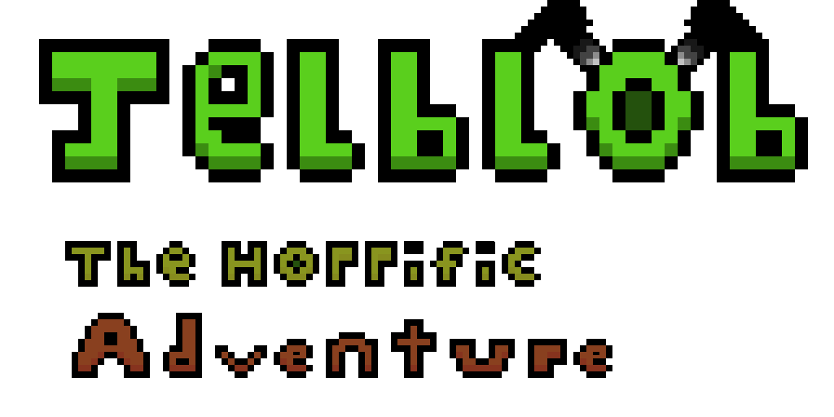

Table of Content

[Role Assignments 3](#_Toc498886877)

[Overview 4](#_Toc498886878)

[Project Brief 4](#_Toc498886879)

[Project Goal 4](#_Toc498886880)

[Software 4](#_Toc498886881)

[Hardware 5](#_Toc498886882)

[Software Development 6](#_Toc498886883)

[Version Control 6](#_Toc498886884)

[Methodology 12](#_Toc498886885)

[Production – Assets and Audio 13](#_Toc498886886)

[Assets 13](#_Toc498886887)

[Audio 23](#_Toc498886888)

[Pseudocode 24](#_Toc498886889)

[(UML – Class Diagrams – Steven) 27](#_Toc498886890)

[Testing – Justification of testing approaches adopted 27](#_Toc498886891)

[Test plan (relate this to Quality Assurance) 27](#_Toc498886892)

[Test Log 28](#_Toc498886893)

[Evaluation of the prototype 56](#_Toc498886894)

[Video demo (copy url into document) 56](#_Toc498886895)

# Role Assignments

|  |  |  |  |
| --- | --- | --- | --- |
| **Name** | **Banner ID** | **Course** | **Role in Project** |
| Alistair Walker | B00305911 | Computer Games Technology | Lead Artist  (With sub roles in Design and Programming) |
| **Description** | | | |
| My role was to provide concept drawings while producing the artwork based on concepts; creating sprites for the characters, blocks and background while making sure each one had an animation provided along with it. I also had sub roles in design and programming, providing feedback on Game Design choices and programming.  I choose the role of Lead Artist because I wanted more experience in art, as previous roles I have undertook in the past of Games Designer and programming; art is a subject I have not touched often, and I believe it’s important to be able to create your own assets. | | | |
| Kenny Melvillie | B00323186 | Games Development | Lead Games Designer, Audio Designer  (With sub roles in Programming and Artist) |
| **Description** | | | |
| I choose to become the lead game designer and lead audio for 2 reasons, the first of which is that I felt that these 2 areas are where I can contribute to the project the best. The 2nd and most important reason is that I have a very strong passion for both of these areas of development and very much enjoy doing them. | | | |
| Steven O’neill | B00339826 | Games Development | Lead Programmer  (With sub roles in Artist and Design) |
| **Description** | | | |
|  | | | |

# Overview

## Project Brief

The purpose of this project, is to develop a working prototype of game as a project team that follows closely to the team’s design and technical design documents. The project team can choose any genre for their specific game, either from a 2D or 3D perspective using the appropriate game engine (Unity, Unreal Engine 4 or Game Maker) to aid their implementation requirements.

For our project, we have tasked ourselves with creating a 2D Side-Scrolling Platformer titled “Jelblob: The Horrific Adventure”, using the game engine ‘Unity’ for development of the title, and coding the game using C# in Visual Studios.

## Project Goal

The aim of this project is to create a playable prototype with at least one level that can be played from start to end. The player controlled character should be able to move left/right and being able to jump as well as firing projectiles, and should be able to end the level by passing a goal which the player must traverse hazards and enemies along the way.

## Software

|  |  |
| --- | --- |
| **Software Used** | **Description** |
| Unity 2017 | The Game Engine that is used for developing the game. |
| Visual Studios 2017 | The Software that is used to code the game. |
| Audacity | The program that is used for recording and editing audio into a suitable format for Unity. |
| Aseprite | The software that is used for the creation of sprite assets (characters, objects, background etc.) and other forms of artwork for Unity. |
| Microsoft Word | The software that is used for the documentation of the project, writing down the design and technical documents. |
| Microsoft PowerPoint | The software that is used to present the game to the audience in a presentation manner. |

## Hardware

|  |
| --- |
| * PC Name – UWS Computer (E113b) * Edition – Windows 10 Enterprise * Processor – Intel(R) Xeon(R) CPU E3-1245 v3 @ 3.40GHz * Installed RAM – 16.0GB * System Type - 64-bit Operating System, x64 Based Processor |

|  |
| --- |
| * PC Name – Firedudeet-PC * Edition – Windows 10 Home * Processor – Intel(R) Core™ i5-3570K CPU @3.40GHz 3.40GHz * Installed RAM – 16.0GB * System Type – 64-bit operating system, x64-based processor |

|  |
| --- |
| * PC Name – DESKTOP-TKITQQ1 * Edition – Windows 10 Home * Processor – Intel(R) Core(TM) i7-6700HQ CPU @ 2.60GHz 2.59Ghz * Installed RAM – 8.00GB * System Type – 64-bit operating system, x64-based processor |

|  |
| --- |
| * PC Name – LAPTOP-9RJJOTB3 * Edition – Windows 10 Home * Processor – Intel(R) Core(TM) i5-6300HQ CPU @ 2.30GHz 2.30GHz * Installed RAM – 16.00GB * System Type – 64-bit operating system, x64-based processor |

# Software Development

## Version Control

For us to successfully complete development of the game, we needed a way to be able to communicate with each other and deliver different versions of files while away from the meetup point in the labs. Throughout the first few weeks we looked at ways in which we could do this, via looking at programs such as Skype, Trello and other programs.

In the end, we settled on 3 different things; the first and second being the different ways of communicating we would use the Student Email System when we couldn’t reach them, and we used a program called ‘Discord’,



<https://discordapp.com/>

<http://globalmodders.net/saigon/wp-content/uploads/2015/08/DS992e2_1.png>

An app created for communication and sharing, this would act as our main way of communication with each other, letting each other know when we had made changes to files, whether we had a question/problem needed solving, or whenever we needed to preview sprite assets before approving to use them for the game.

However, apart from communication we also needed a better way of allowing access to any assets, files and the game, in which we would be able to download online instead of passing new files when we meet up. We couldn’t use the Student Email or Discord to pass files along, as there is usually a file size cap which prevents sending big files through their services. So following some recommendations and suggestions, we used a program called ‘GitHub’ to transfer and replace files,



<https://github.com/>

<https://1n3qgw368xwl1cx1o7p18wfg-wpengine.netdna-ssl.com/wp-content/uploads/2017/02/github-bb449e0ffbacbcb7f9c703db85b1cf0b.png>

We chose this service to store our files because it was simple to use and good control of organizing files, even for someone who had little knowledge on how to use the service would still be able to upload files and know where they are.

Below are screenshots of when files were uploaded to Github, and when anyone added new files / updated files in folders.

GitHub – Desktop Version Screenshots

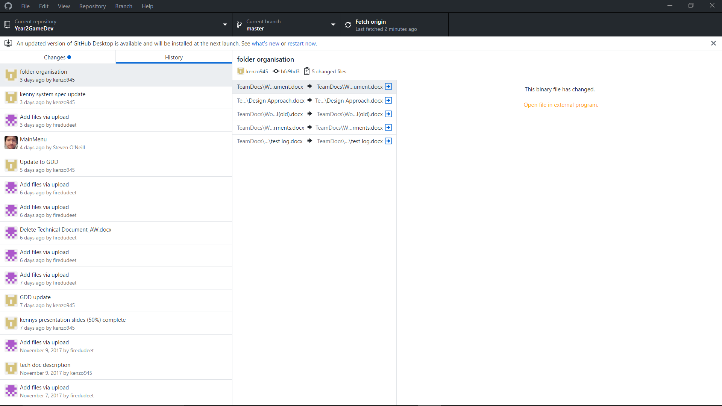

GitHub – Web Browser Version Screenshots

**September**

**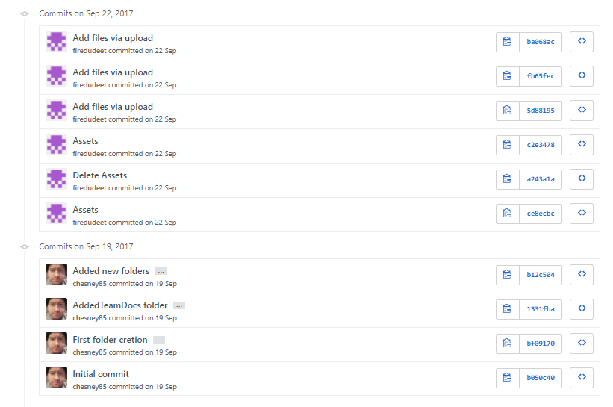**

**September – October**

**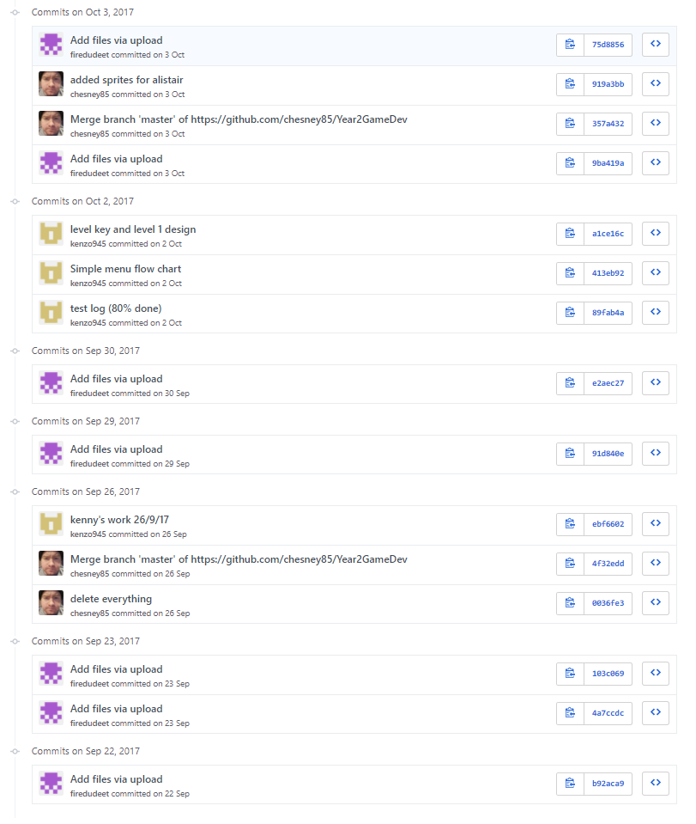**

**October**

**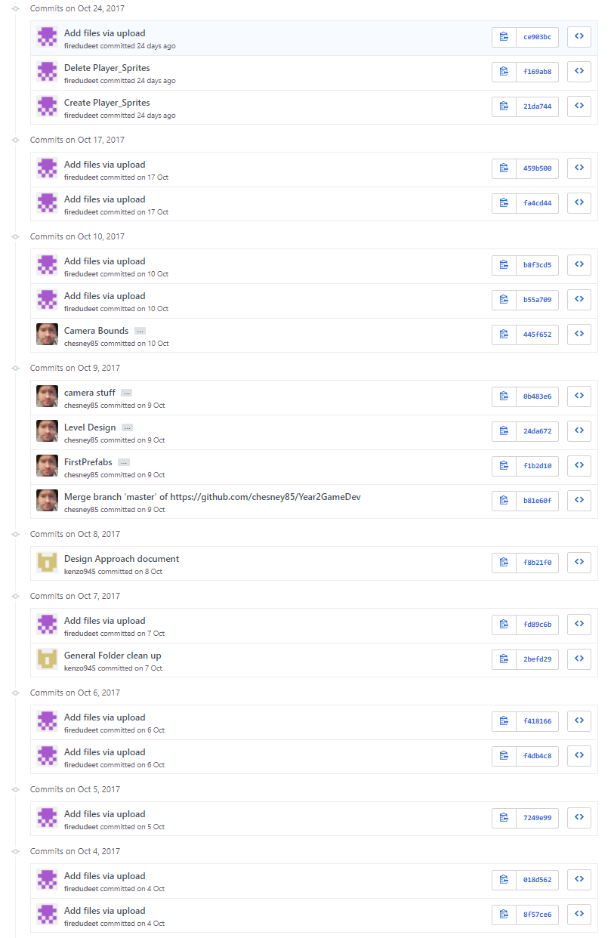**

**October – November**

**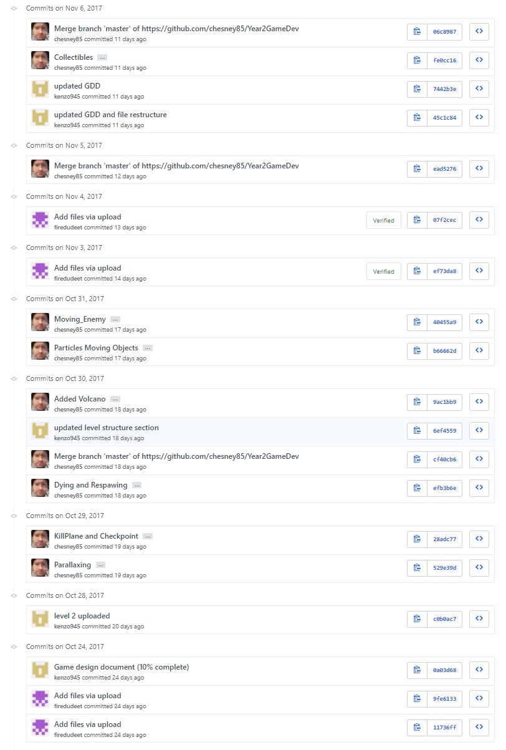**

**November**

**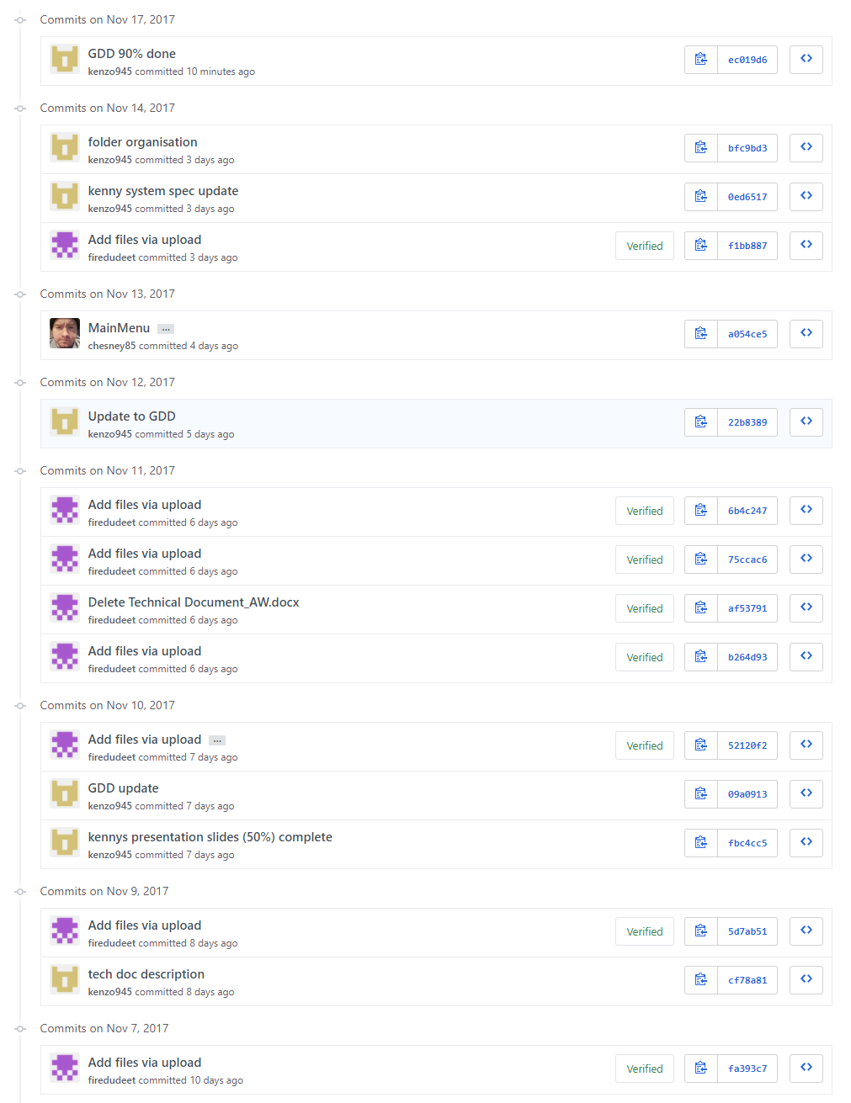**

## Methodology

Our design approach for this project will be agile development. Agile is a lightweight development method for software and game development which values:

* Individuals and interactions: in agile development, self-organization and motivation are important, as are interactions like co-location and pair programming.
* Working software: working software is more useful and welcome than just presenting documents to clients in meetings.
* Customer collaboration: requirements cannot be fully collected at the beginning of the software development cycle, therefore continuous customer or stakeholder involvement is very important.
* Responding to change: agile development is focused on quick responses to change and continuous development

***manifesto of agile development from*** <http://en.wikipedia.org/wiki/Agile_software_development#Predecessors>

Agile development is based on 12 key principles:

1. Customer satisfaction by rapid delivery of useful software
2. Welcome changing requirements, even late in development
3. Working software is delivered frequently (weeks rather than months)
4. Close, daily cooperation between business people and developers
5. Projects are built around motivated individuals, who should be trusted
6. Face-to-face conversation is the best form of communication (co-location)
7. Working software is the principal measure of progress
8. Sustainable development, able to maintain a constant pace
9. Continuous attention to technical excellence and good design
10. Simplicity—the art of maximizing the amount of work not done—is essential
11. Self-organizing teams
12. Regular adaptation to changing circumstance

***Principles of agile development from*** <http://en.wikipedia.org/wiki/Agile_software_development#Predecessors>

http://agilemanifesto.org/

In comparison to other design approaches such as Rapid Application development, agile is much more versatile and does not require specialist software to use and unlike with Rapid application development it is very simple and quick to change certain aspects of your game at the drop of a hat.

The main reasons we have chosen to use Agile development for my approach is because with agile development there is a higher emphasis on working software over high amounts of paperwork which suits us perfectly due to a desire for focusing more time in more important areas.

Another advantage / reason for choosing agile development is that you can very easily make changes to your project regardless of how far into development you are allowing us to easily make changes to aspects of my game or add new features in such as new enemy types or unique level feature.

A big advantage to agile development for us is that due to agile planning not being so strict we can within reason pick and choose which aspect of development to focus on in a day to day basis meaning that if we are having a problem with a particular piece of implementation that we just can’t figure out then with agile development we can easily shift to do something else until a solution to the initial problem arises.

## Production – Assets and Audio

### Assets

Aseprite

This is the software that can be purchased via Steam, which is used to create the sprite assets of the game. Thanks to its many features and user friendly interface, it was easy to pick up and use; allowing to create many detailed sprites that allowed to create multiple images (.png’s) for animations.

|  |  |  |
| --- | --- | --- |
| **Sprite / Image / Texture** | **Information** | **Filename** |
|  |  |  |
| LavaLevelGroundBlock1_Enlarged-sheet | A texture sprite block that was created with the use of the program, “Aseprite”, it is used as the top layer of the ground for the Lava Level. | **LavaLevelGroundBlock1\_Enlarged1.png**  **LavaLevelGroundBlock1\_Enlarged2.png**  **LavaLevelGroundBlock1\_Enlarged3.png**  **LavaLevelGroundBlock1\_Enlarged4.png**  **LavaLevelGroundBlock1\_Enlarged5.png**  **LavaLevelGroundBlock1\_Enlarged6.png**  **LavaLevelGroundBlock1\_Enlarged7.png**  **LavaLevelGroundBlock1\_Enlarged8.png**  **LavaLevelGroundBlock1\_Enlarged-sheet.png** |
| LavaLevelGroundBlock2_Enlarged-sheet | A texture sprite block that was created with the use of the program, “Aseprite”, it is used as the bottom layer of the ground for the Lava Level. | **LavaLevelGroundBlock2\_Enlarged1.png**  **LavaLevelGroundBlock2\_Enlarged2.png**  **LavaLevelGroundBlock2\_Enlarged3.png**  **LavaLevelGroundBlock2\_Enlarged4.png**  **LavaLevelGroundBlock2\_Enlarged5.png**  **LavaLevelGroundBlock2\_Enlarged6.png**  **LavaLevelGroundBlock2\_Enlarged7.png**  **LavaLevelGroundBlock2\_Enlarged8.png**  **LavaLevelGroundBlock2\_Enlarged-sheet.png** |
| LavaLevelGroundBlockEnd1_Enlarged-sheet | A texture sprite block that was created with the use of the program, “Aseprite”, it is used as the top layer of the edge corner ground for the Lava Level. | **LavaLevelGroundBlockEnd1\_Enlarged1.png**  **LavaLevelGroundBlockEnd1\_Enlarged2.png**  **LavaLevelGroundBlockEnd1\_Enlarged3.png**  **LavaLevelGroundBlockEnd1\_Enlarged4.png**  **LavaLevelGroundBlockEnd1\_Enlarged5.png**  **LavaLevelGroundBlockEnd1\_Enlarged6.png**  **LavaLevelGroundBlockEnd1\_Enlarged7.png**  **LavaLevelGroundBlockEnd1\_Enlarged8.png**  **LavaLevelGroundBlockEnd1\_Enlarged9.png**  **LavaLevelGroundBlockEnd1\_Enlarged10.png**  **LavaLevelGroundBlockEnd1\_Enlarged11.png**  **LavaLevelGroundBlockEnd1\_Enlarged12.png**  **LavaLevelGroundBlockEnd1\_Enlarged13.png**  **LavaLevelGroundBlockEnd1\_Enlarged14.png**  **LavaLevelGroundBlockEnd1\_Enlarged15.png**  **LavaLevelGroundBlockEnd1\_Enlarged16.png**  **LavaLevelGroundBlockEnd1\_Enlarged-sheet.png** |
| LavaLevelGroundBlockEnd2_Enlarged-sheet | A texture sprite block that was created with the use of the program, “Aseprite”, it is used as the bottom layer of the edge corner ground for the Lava Level. | **LavaLevelGroundBlockEnd2\_Enlarged1.png**  **LavaLevelGroundBlockEnd2\_Enlarged2.png**  **LavaLevelGroundBlockEnd2\_Enlarged3.png**  **LavaLevelGroundBlockEnd2\_Enlarged4.png**  **LavaLevelGroundBlockEnd2\_Enlarged5.png**  **LavaLevelGroundBlockEnd2\_Enlarged6.png**  **LavaLevelGroundBlockEnd2\_Enlarged7.png**  **LavaLevelGroundBlockEnd2\_Enlarged8.png**  **LavaLevelGroundBlockEnd2\_Enlarged9.png**  **LavaLevelGroundBlockEnd2\_Enlarged10.png**  **LavaLevelGroundBlockEnd2\_Enlarged11.png**  **LavaLevelGroundBlockEnd2\_Enlarged12.png**  **LavaLevelGroundBlockEnd2\_Enlarged13.png**  **LavaLevelGroundBlockEnd2\_Enlarged14.png**  **LavaLevelGroundBlockEnd2\_Enlarged15.png**  **LavaLevelGroundBlockEnd2\_Enlarged16.png**  **LavaLevelGroundBlockEnd2\_Enlarged-sheet.png** |
| LavaLevelFlyingBlock1_Enlarged-sheet | A texture sprite block that was created with the use of the program, “Aseprite”, it is used as a floating block for platforming for the lava level. | **LavaLevelFlyingBlock1\_Enlarged1.png**  **LavaLevelFlyingBlock1\_Enlarged2.png**  **LavaLevelFlyingBlock1\_Enlarged3.png**  **LavaLevelFlyingBlock1\_Enlarged4.png**  **LavaLevelFlyingBlock1\_Enlarged5.png**  **LavaLevelFlyingBlock1\_Enlarged6.png**  **LavaLevelFlyingBlock1\_Enlarged7.png**  **LavaLevelFlyingBlock1\_Enlarged8.png**  **LavaLevelFlyingBlock1\_Enlarged-sheet.png** |
| LavaLevelMovingBlockEdge_Enlarged-sheet | A texture sprite block that was created with the use of the program, “Aseprite”, it is used as a moving platform for platforming onto for the lava level. | **LavaLevelMovingBlockEdge\_Enlarged1.png**  **LavaLevelMovingBlockEdge\_Enlarged2.png**  **LavaLevelMovingBlockEdge\_Enlarged3.png**  **LavaLevelMovingBlockEdge\_Enlarged4.png**  **LavaLevelMovingBlockEdge\_Enlarged5.png**  **LavaLevelMovingBlockEdge\_Enlarged6.png**  **LavaLevelMovingBlockEdge\_Enlarged7.png**  **LavaLevelMovingBlockEdge\_Enlarged8.png**  **LavaLevelMovingBlockEdge\_Enlarged9.png**  **LavaLevelMovingBlockEdge\_Enlarged10.png**  **LavaLevelMovingBlockEdge\_Enlarged11.png**  **LavaLevelMovingBlockEdge\_Enlarged12.png**  **LavaLevelMovingBlockEdge\_Enlarged-sheet.png** |
| LavaLevelSlippyBlockEnd_Enlarged-sheet | A texture sprite block that was created with the use of the program, “Aseprite”, it is used as an edge corner block for slippy surfaces. | **LavaLevelSlippyBlockEnd\_Enlarged1.png**  **LavaLevelSlippyBlockEnd\_Enlarged2.png**  **LavaLevelSlippyBlockEnd\_Enlarged-sheet.png** |
| LavaLevelSlippyBlockMid_Enlarged-sheet | A texture sprite block that was created with the use of the program, “Aseprite”, it is used to represent slippy blocks. | **LavaLevelSlippyBlockMid\_Enlarged1.png**  **LavaLevelSlippyBlockMid\_Enlarged2.png**  **LavaLevelSlippyBlockMid\_Enlarged-sheet.png** |
| LavaLevelUnstableGroundBlock_Enlarged-sheet | A texture sprite block that was created with the use of the program, “Aseprite”, it is used as a disappearing platform when the player jumps on it. | **LavaLevelUnstableGroundBlock\_Enlarged1.png**  **LavaLevelUnstableGroundBlock\_Enlarged2.png**  **LavaLevelUnstableGroundBlock\_Enlarged3.png**  **LavaLevelUnstableGroundBlock\_Enlarged4.png**  **LavaLevelUnstableGroundBlock\_Enlarged5.png**  **LavaLevelUnstableGroundBlock\_Enlarged6.png**  **LavaLevelUnstableGroundBlock\_Enlarged7.png**  **LavaLevelUnstableGroundBlock\_Enlarged8.png**  **LavaLevelUnstableGroundBlock\_Enlarged9.png**  **LavaLevelUnstableGroundBlock\_Enlarged10.png**  **LavaLevelUnstableGroundBlock\_Enlarged11.png**  **LavaLevelUnstableGroundBlock\_Enlarged12.png**  **LavaLevelUnstableGroundBlock\_Enlarged13.png**  **LavaLevelUnstableGroundBlock\_Enlarged14.png**  **LavaLevelUnstableGroundBlock\_Enlarged15.png**  **LavaLevelUnstableGroundBlock\_Enlarged16.png**  **LavaLevelUnstableGroundBlock\_Enlarged17.png**  **LavaLevelUnstableGroundBlock\_Enlarged18.png**  **LavaLevelUnstableGroundBlock\_Enlarged19.png**  **LavaLevelUnstableGroundBlock\_Enlarged20.png**  **LavaLevelUnstableGroundBlock\_Enlarged21.png**  **LavaLevelUnstableGroundBlock\_Enlarged-sheet.png** |
|  |  |  |
| LavaLevelDeathWallBlock-sheet | A texture sprite block that was created with the use of the program, “Aseprite”, it is used as the body of the hazard known as Lava Death Wall. | **LavaLevelDeathWallBlock1.png**  **LavaLevelDeathWallBlock2.png**  **LavaLevelDeathWallBlock3.png**  **LavaLevelDeathWallBlock-sheet.png** |
| LavaLevelDeathWallMain-sheet | A texture sprite block that was created with the use of the program, “Aseprite”, it is used as the top representation of the hazard known as Lava Death Wall. | **LavaLevelDeathWallMain1.png LavaLevelDeathWallMain2.png LavaLevelDeathWallMain3.png LavaLevelDeathWallMain-sheet.png** |
| LavaLevelLavaGyserBlock-sheet | A texture sprite block that was created with the use of the program, “Aseprite”, it is used as the body of the hazard known as Lava Gyser. | **LavaLevelLavaGyserBlock1.png**  **LavaLevelLavaGyserBlock2.png**  **LavaLevelLavaGyserBlock3.png**  **LavaLevelLavaGyser-sheet.png** |
| LavaLevelLavaGyser-sheet | A texture sprite block that was created with the use of the program, “Aseprite”, it is used as the top representation of the hazard known as Lava Gyser. | **LavaLevelLavaGyser1.png**  **LavaLevelLavaGyser2.png**  **LavaLevelLavaGyser3.png**  **LavaLevelLavaGyser-sheet.png** |
|  |  |  |
| Player_Jelblolb-sheet | Sprite images/sheet that was created with the use of a program, “Aseprite”, they make up the look of the player, Jelblob. There is a total of 37 sprites, 24 of the sprites which make up the main body of the player, with the first 8 making up the default size of the player which contains animations for idle, moving and jumping, the next 8 making up the medium size of the player which has the same animations as the previous, and the last 8 make up the small size of the player with the same animations of the previously mentioned. There is 9 different sprites for the eyes of the player, with 6 of the sprites making up the animation for the player idling, 1 sprite makes up whenever the player is moving in a direction, and the last 2 sprites are for when the player jumping (one going up, one going down). The last 4 sprites out of the sprite sheet is for animation of the mouth of the player, which plays when the player is shooting. | **Player\_Jelblolb\_DefaultSizeBody\_1.png**  **Player\_Jelblolb\_DefaultSizeBody\_2.png**  **Player\_Jelblolb\_DefaultSizeBody\_3.png**  **Player\_Jelblolb\_DefaultSizeBody\_4.png**  **Player\_Jelblolb\_DefaultSizeBody\_5.png**  **Player\_Jelblolb\_DefaultSizeBody\_6.png**  **Player\_Jelblolb\_DefaultSizeBody\_7.png**  **Player\_Jelblolb\_DefaultSizeBody\_8.png**  **Player\_Jelblolb\_MediumSizeBody\_9.png**  **Player\_Jelblolb\_MediumSizeBody\_10.png**  **Player\_Jelblolb\_MediumSizeBody\_11.png**  **Player\_Jelblolb\_MediumSizeBody\_12.png**  **Player\_Jelblolb\_MediumSizeBody\_13.png**  **Player\_Jelblolb\_MediumSizeBody\_14.png**  **Player\_Jelblolb\_MediumSizeBody\_15.png**  **Player\_Jelblolb\_MediumSizeBody\_16.png**  **Player\_Jelblolb\_SmallSizeBody\_17.png**  **Player\_Jelblolb\_SmallSizeBody\_18.png**  **Player\_Jelblolb\_SmallSizeBody\_19.png**  **Player\_Jelblolb\_SmallSizeBody\_20.png**  **Player\_Jelblolb\_SmallSizeBody\_21.png**  **Player\_Jelblolb\_SmallSizeBody\_22.png**  **Player\_Jelblolb\_SmallSizeBody\_23.png**  **Player\_Jelblolb\_SmallSizeBody\_24.png**  **Player\_Jelblolb\_IdleEyes\_25.png**  **Player\_Jelblolb\_IdleEyes\_26.png**  **Player\_Jelblolb\_IdleEyes\_27.png**  **Player\_Jelblolb\_IdleEyes\_28.png**  **Player\_Jelblolb\_IdleEyes\_29.png**  **Player\_Jelblolb\_IdleEyes\_30.png**  **Player\_Jelblolb\_MovingEyes\_31.png**  **Player\_Jelblolb\_LookingUpEyes\_32.png**  **Player\_Jelblolb\_LookingDownEyes\_33.png**  **Player\_Jelblolb\_Mouth\_34.png**  **Player\_Jelblolb\_Mouth\_35.png**  **Player\_Jelblolb\_Mouth\_36.png**  **Player\_Jelblolb\_Mouth\_37.png**  **Player\_Jelblolb-sheet.png** |
| Enemy_Navigator-sheet | Sprite images/sheet that was created with the use of a program, “Aseprite”, they make up the look of the enemy, Navigator; the sprite sheet contains 8 images for when moving left, and 8 images for when moving right. | **Enemy\_Navigator1.png**  **Enemy\_Navigator2.png**  **Enemy\_Navigator3.png**  **Enemy\_Navigator4.png**  **Enemy\_Navigator5.png**  **Enemy\_Navigator6.png**  **Enemy\_Navigator7.png**  **Enemy\_Navigator8.png**  **Enemy\_Navigator9.png**  **Enemy\_Navigator10.png**  **Enemy\_Navigator11.png**  **Enemy\_Navigator12.png**  **Enemy\_Navigator13.png**  **Enemy\_Navigator14.png**  **Enemy\_Navigator15.png**  **Enemy\_Navigator16.png**  **Enemy\_Navigator-sheet.png** |
| Enemy_NavigatorWithBounceHelm-sheet | Sprite images/sheet that was created with the use of a program, “Aseprite”, they make up the look of the enemy, Navigator With Bounce Helm; the sprite sheet contains 8 images for when moving left, and 8 images for when moving right. | **Enemy\_NavigatorWithBounceHelm1.png**  **Enemy\_NavigatorWithBounceHelm2.png**  **Enemy\_NavigatorWithBounceHelm3.png**  **Enemy\_NavigatorWithBounceHelm4.png**  **Enemy\_NavigatorWithBounceHelm5.png**  **Enemy\_NavigatorWithBounceHelm6.png**  **Enemy\_NavigatorWithBounceHelm7.png**  **Enemy\_NavigatorWithBounceHelm8.png**  **Enemy\_NavigatorWithBounceHelm9.png**  **Enemy\_NavigatorWithBounceHelm10.png**  **Enemy\_NavigatorWithBounceHelm11.png**  **Enemy\_NavigatorWithBounceHelm12.png**  **Enemy\_NavigatorWithBounceHelm13.png**  **Enemy\_NavigatorWithBounceHelm14.png**  **Enemy\_NavigatorWithBounceHelm15.png**  **Enemy\_NavigatorWithBounceHelm16.png**  **Enemy\_NavigatorWithBounceHelm-sheet.png** |
| Enemy_Patroller-sheet | Sprite images/sheet that was created with the use of a program, “Aseprite”, they make up the look of the enemy, Patroller; the sprite sheet contains 4 images which show off the rockets which keep the enemy in the air. | **Enemy\_Patroller1.png**  **Enemy\_Patroller2.png**  **Enemy\_Patroller3.png**  **Enemy\_Patroller4.png**  **Enemy\_Patroller-sheet.png** |
| Enemy_SkyPatroller-sheet | Sprite images/sheet that was created with the use of a program, “Aseprite”, they make up the look of the enemy, Sky Patroller; the sprite sheet contains 4 images which show off the rockets which keep the enemy in the air. | **Enemy\_SkyPatroller1.png**  **Enemy\_SkyPatroller2.png**  **Enemy\_SkyPatroller3.png**  **Enemy\_SkyPatroller4.png**  **Enemy\_SkyPatroller-sheet.png** |
| Enemy_HeavyMagPatroller-sheet | Sprite images/sheet that was created with the use of a program, “Aseprite”, they make up the look the enemy, Heavy Mag Patroller; the sprite sheet contains 12 images, 4 which shows the enemy with the turret (but no animations for the turret), 4 which shows the enemy without the turret, and 4 which shows only the turret. These previous 8 images are meant to be combined together in one object. | **Enemy\_HeavyMagPatroller\_WithGun1.png**  **Enemy\_HeavyMagPatroller\_WithGun2.png**  **Enemy\_HeavyMagPatroller\_WithGun3.png**  **Enemy\_HeavyMagPatroller\_WithGun4.png**  **Enemy\_HeavyMagPatroller\_NoGun1.png**  **Enemy\_HeavyMagPatroller\_NoGun2.png**  **Enemy\_HeavyMagPatroller\_NoGun3.png**  **Enemy\_HeavyMagPatroller\_NoGun4.png**  **Enemy\_HeavyMagPatroller\_Turret1.png**  **Enemy\_HeavyMagPatroller\_Turret2.png**  **Enemy\_HeavyMagPatroller\_Turret3.png**  **Enemy\_HeavyMagPatroller\_Turret4.png**  **Enemy\_HeavyMagPatroller-sheet.png** |
| Enemy_Stickler-sheet | Sprite images/sheet that was created with the use of a program, “Aseprite”, they make up the look the enemy, Stickler; the sprite sheet contains 9 images, 7 which play when the enemy is inactive / sleeping, and 2 at the end play in a loop when the enemy is active/awake. | **Enemy\_Stickler1.png**  **Enemy\_Stickler2.png**  **Enemy\_Stickler3.png**  **Enemy\_Stickler4.png**  **Enemy\_Stickler5.png**  **Enemy\_Stickler6.png**  **Enemy\_Stickler7.png**  **Enemy\_Stickler8.png**  **Enemy\_Stickler9.png**  **Enemy\_Stickler-sheet.png** |
| Enemy_SticklerGoneHaywire-sheet | Sprite images/sheet that was created with the use of a program, “Aseprite”, they make up the look the enemy, Stickler Gone Haywire; the sprite sheet contains 11 images, 9 which play while the enemy is not totally aggressive, and 2 at the end play in a loop when the enemy is totally aggressive. | **Enemy\_SticklerGoneHaywire1.png**  **Enemy\_SticklerGoneHaywire2.png**  **Enemy\_SticklerGoneHaywire3.png**  **Enemy\_SticklerGoneHaywire4.png**  **Enemy\_SticklerGoneHaywire5.png**  **Enemy\_SticklerGoneHaywire6.png**  **Enemy\_SticklerGoneHaywire7.png**  **Enemy\_SticklerGoneHaywire8.png**  **Enemy\_SticklerGoneHaywire9.png**  **Enemy\_SticklerGoneHaywire10.png**  **Enemy\_SticklerGoneHaywire11.png**  **Enemy\_SticklerGoneHaywire-sheet.png** |
| Enemy_Enforcer-sheet | Sprite images/sheet that was created with the use of a program, “Aseprite”, they make up the look the enemy, Enforcer; the sprite sheet contains 33 images, 10 which shows the enemy with the turret (but no animations for the turret), 10 which shows the enemy without the turret, and 13 which shows only the turret. The previous 23 images are meant to be combined together in one object. | **Enemy\_Enforcer\_WithGun1.png**  **Enemy\_Enforcer\_WithGun2.png**  **Enemy\_Enforcer\_WithGun3.png**  **Enemy\_Enforcer\_WithGun4.png**  **Enemy\_Enforcer\_WithGun5.png**  **Enemy\_Enforcer\_WithGun6.png**  **Enemy\_Enforcer\_WithGun7.png**  **Enemy\_Enforcer\_WithGun8.png**  **Enemy\_Enforcer\_WithGun9.png**  **Enemy\_Enforcer\_WithGun10.png**  **Enemy\_Enforcer\_NoGun1.png**  **Enemy\_Enforcer\_NoGun2.png**  **Enemy\_Enforcer\_NoGun3.png**  **Enemy\_Enforcer\_NoGun4.png**  **Enemy\_Enforcer\_NoGun5.png**  **Enemy\_Enforcer\_NoGun6.png**  **Enemy\_Enforcer\_NoGun7.png**  **Enemy\_Enforcer\_NoGun8.png**  **Enemy\_Enforcer\_NoGun9.png**  **Enemy\_Enforcer\_NoGun10.png**  **Enemy\_Enforcer\_Turret1.png**  **Enemy\_Enforcer\_Turret2.png**  **Enemy\_Enforcer\_Turret3.png**  **Enemy\_Enforcer\_Turret4.png**  **Enemy\_Enforcer\_Turret5.png**  **Enemy\_Enforcer\_Turret6.png**  **Enemy\_Enforcer\_Turret7.png**  **Enemy\_Enforcer\_Turret8.png**  **Enemy\_Enforcer\_Turret9.png**  **Enemy\_Enforcer\_Turret10.png**  **Enemy\_Enforcer\_Turret11.png**  **Enemy\_Enforcer\_Turret12.png**  **Enemy\_Enforcer\_Turret13.png**  **Enemy\_Enforcer-sheet.png** |
| Enemy_ColdEnforcer-sheet | Sprite images/sheet that was created with the use of a program, “Aseprite”, they make up the look the enemy, Cold Enforcer; the sprite sheet contains 28 images, 8 which shows the enemy with the turret (but no animations for the turret), 8 which shows the enemy without the turret, and 12 which shows only the turret. The previous 20 images are meant to be combined together in one object. | **Enemy\_ColdEnforcer\_WithGun1.png**  **Enemy\_ColdEnforcer\_WithGun2.png**  **Enemy\_ColdEnforcer\_WithGun3.png**  **Enemy\_ColdEnforcer\_WithGun4.png**  **Enemy\_ColdEnforcer\_WithGun5.png**  **Enemy\_ColdEnforcer\_WithGun6.png**  **Enemy\_ColdEnforcer\_WithGun7.png**  **Enemy\_ColdEnforcer\_WithGun8.png**  **Enemy\_ColdEnforcer\_NoGun1.png**  **Enemy\_ColdEnforcer\_NoGun2.png**  **Enemy\_ColdEnforcer\_NoGun3.png**  **Enemy\_ColdEnforcer\_NoGun4.png**  **Enemy\_ColdEnforcer\_NoGun5.png**  **Enemy\_ColdEnforcer\_NoGun6.png**  **Enemy\_ColdEnforcer\_NoGun7.png**  **Enemy\_ColdEnforcer\_NoGun8.png**  **Enemy\_ColdEnforcer\_Turret1.png**  **Enemy\_ColdEnforcer\_Turret2.png**  **Enemy\_ColdEnforcer\_Turret3.png**  **Enemy\_ColdEnforcer\_Turret4.png**  **Enemy\_ColdEnforcer\_Turret5.png**  **Enemy\_ColdEnforcer\_Turret6.png**  **Enemy\_ColdEnforcer\_Turret7.png**  **Enemy\_ColdEnforcer\_Turret8.png**  **Enemy\_ColdEnforcer\_Turret9.png**  **Enemy\_ColdEnforcer\_Turret10.png**  **Enemy\_ColdEnforcer\_Turret11.png Enemy\_ColdEnforcer\_Turret12.png**  **Enemy\_ColdEnforcer-sheet.png** |
| Enemy_FinalEnforcer_SB-sheet | Sprite images/sheet that was created with the use of a program, “Aseprite”, they make up the look the enemy, Final Enforcer; the sprite sheet contains 15 images, 1 which shows the enemy in its default/neutral state, 2 which shows the enemy in its firing giant laser beam state that loops, 9 which shows the enemy charging and firing bouncy projectiles, and 3 which are used as an afterimage effect when enemy is moving to new location. | **Enemy\_FinalEnforcer\_SB1.png**  **Enemy\_FinalEnforcer\_SB2.png**  **Enemy\_FinalEnforcer\_SB3.png**  **Enemy\_FinalEnforcer\_SB4.png**  **Enemy\_FinalEnforcer\_SB5.png**  **Enemy\_FinalEnforcer\_SB6.png**  **Enemy\_FinalEnforcer\_SB7.png**  **Enemy\_FinalEnforcer\_SB8.png**  **Enemy\_FinalEnforcer\_SB9.png**  **Enemy\_FinalEnforcer\_SB10.png**  **Enemy\_FinalEnforcer\_SB11.png**  **Enemy\_FinalEnforcer\_SB12.png**  **Enemy\_FinalEnforcer\_SB13.png**  **Enemy\_FinalEnforcer\_SB14.png**  **Enemy\_FinalEnforcer\_SB15.png**  **Enemy\_FinalEnforcer-sheet.png** |
|  |  |  |
| C:\Users\Firedudeet\AppData\Local\Microsoft\Windows\INetCache\Content.Word\LavaLevelBackgroundAssetVolcano-sheet.png | Sprite image/sheet that was created with the use of a program, “Aseprite”, it makes up the look of the volcano that is seen in the background of the lava level. | **LavaLevelBackgroundAssetVolcano1**  **LavaLevelBackgroundAssetVolcano2**  **LavaLevelBackgroundAssetVolcano-sheet** |
|  |  |  |

### Audio

Audacity

This is the software that can be downloaded for free from AudacityTeam.org, which can used to create and edit the audio for the game. Audacity allows for great control over audio, lettings users increase and decrease the pitch of the sounds, add additional effects to create new sounds; and best of all, it’s free and lets users produce quality sounds.

|  |  |  |
| --- | --- | --- |
| **Audio / Sound Effects** | **Information** | **Filename** |
|  | Sound effect that was created and edited using “Audacity”, it is heard when the player jumps using the space bar in the game. | playerJump.aup  playerJump.wav |
|  | Sound effect that was created and edited using “Audacity”, it is heard | playercelebration.aup  playercelebration.wav |
|  | Sound effect that was created and edited using “Audacity”, it is heard whenever the player dies to a hazard / enemy. | playerdeath.aup  playerdeath.wav |
|  | Sound effect that was created and edited using “Audacity”, it is heard whenever the player pressed the down key to shoot. | playershoot.aup  playershoot.wav |
|  | Sound effect that was created and edited using “Audacity”, it is heard whenever an enemy is defeated. | enemyDeath.aup  enemyDeath.wav |

## Pseudocode

PlayerController

This sample code from the PlayerController script, is for setting up physics, collisions and controls for the player object.

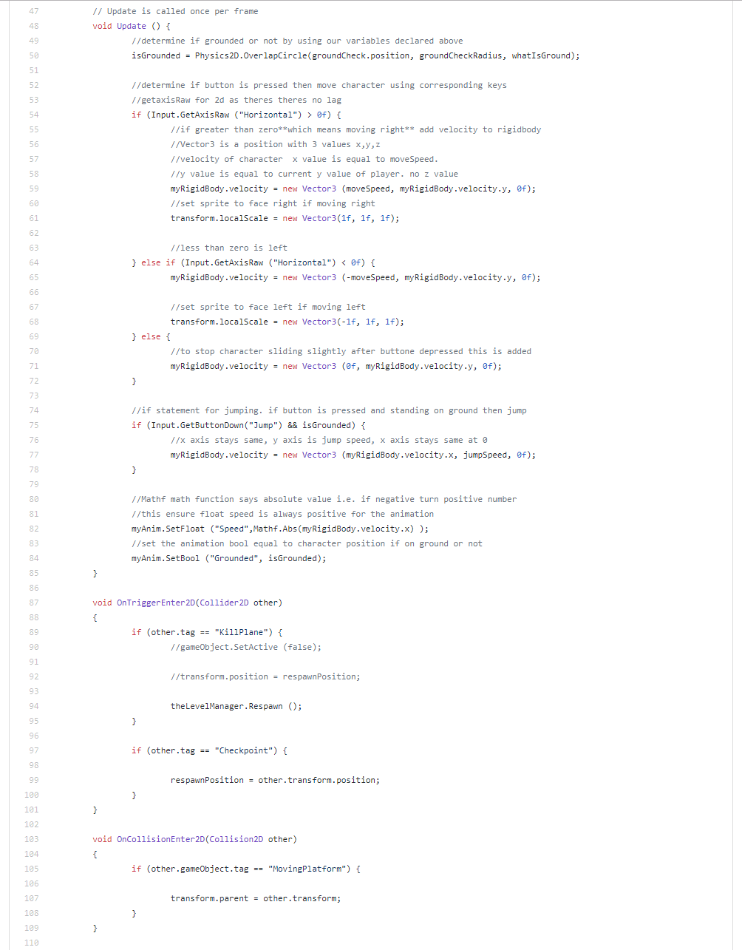

Parallaxing

This code from the Parallaxing script, creates the effect in which the background in the game, moves with the camera behind a bit.

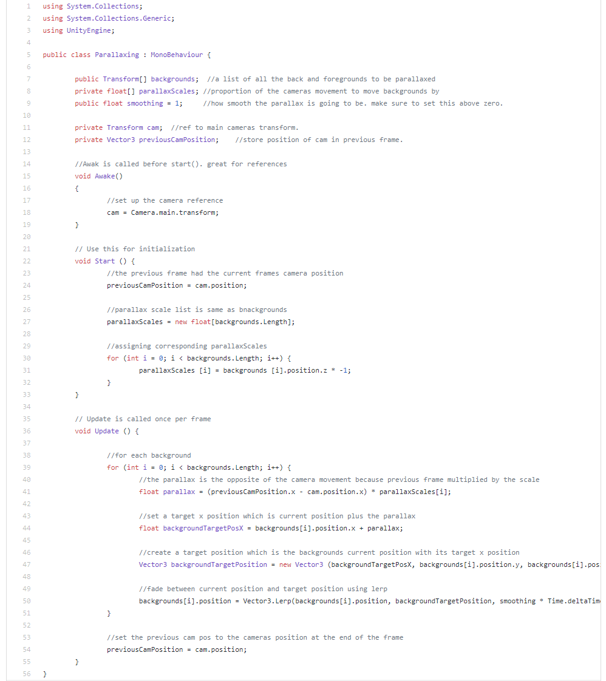

CameraControlller

This code from the CameraController script, allows the camera to follow the player throughout the level while staying within the bounds of the level.

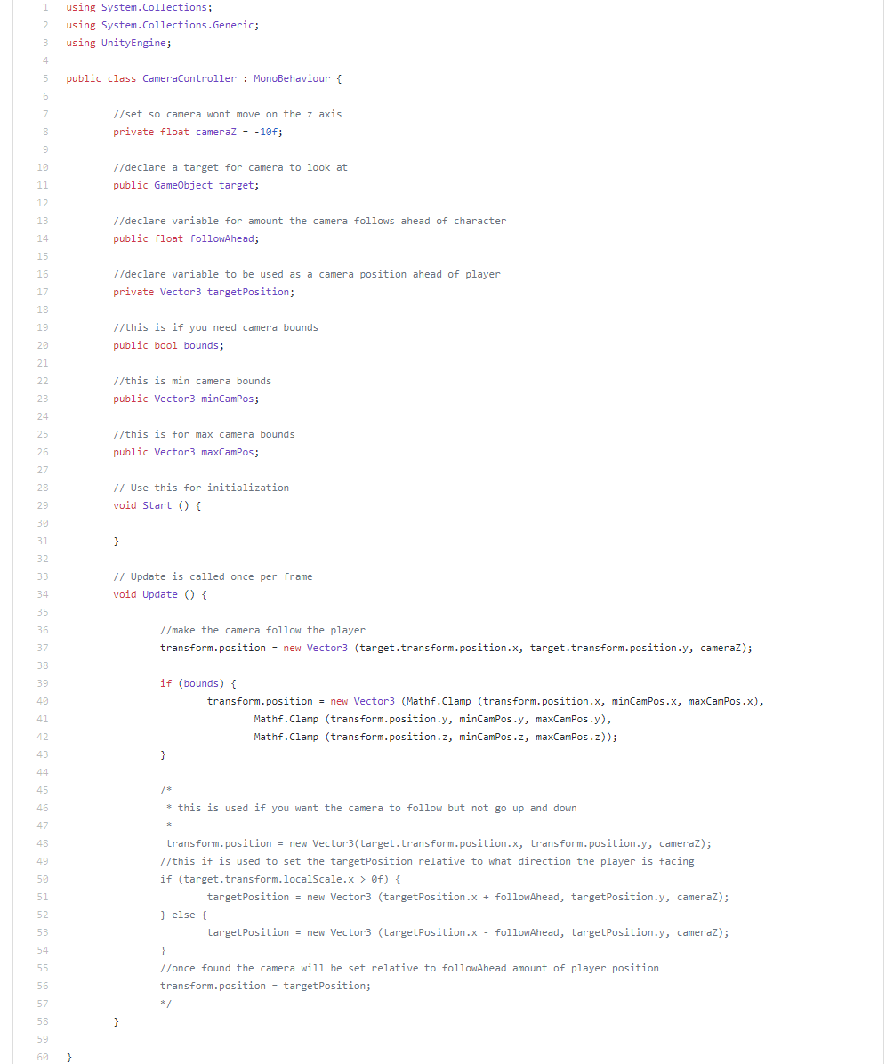

## (UML – Class Diagrams – Steven)

UI (detail this here)

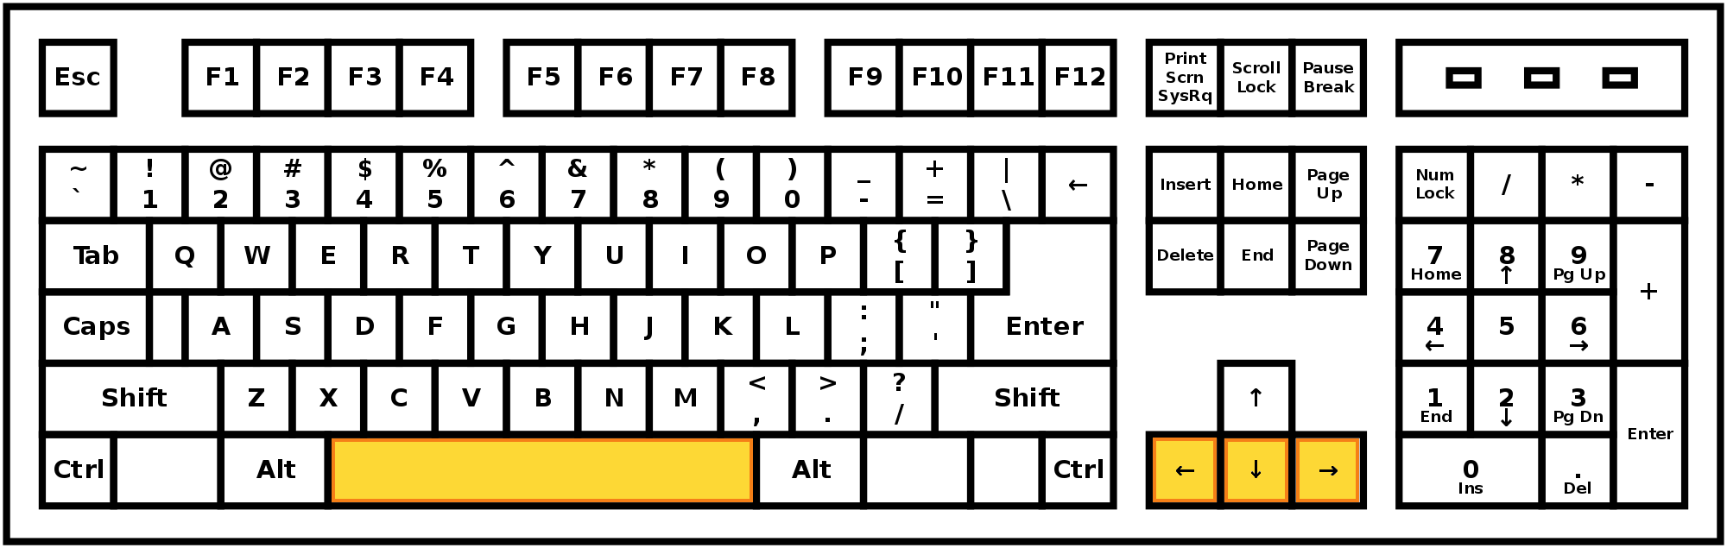

**Shoot**

**Move Right**

**Move Left**

**Jump**

* Space Bar Key: Makes the Player Jump
* Left Arrow Key: Move the player Left
* Down Arrow Key: Makes the player shoot a projectile.
* Right Arrow Key: Move the player Right

# Testing – Justification of testing approaches adopted

## Test plan (relate this to Quality Assurance)

## Test Log

|  |  |  |  |  |  |  |
| --- | --- | --- | --- | --- | --- | --- |
| **Test Log** | | | | | | |
| **Test case** | **Requirement no. / Item being tested** | **Test Data / how to test** | **Expected Result** | **Actual Result** | **Test Outcome** | **Comments** |
| **Player Movement Tests** | | | | | | |
| 1 | Player Movement (left) | Press “Left Arrow” key while on any level | Player will move to the left and then stop |  |  |  |
| 2 | Player Movement (left) | Press and Hold the “Left Arrow” key while on any level | Player will move to the left and continue moving until the “A” key is let go |  |  |  |
| 3 | Player Movement (Right) | Press “Right Arrow” key while on any level | Player will move to the right and then stop |  |  |  |
| 4 | Player Movement (Right) | Press and hold the “Right Arrow” key while on any level | Player will move to the right and continue moving until the “D” key is let go |  |  |  |
| 5 | Player Jump  (stationary/Max mass) | Press the “space bar” while at max mass and without moving left or right | Player will jump to max height (???) and then land back where it jumped from |  |  |  |
| 6 | Player Jump (stationary/Medium mass) | Press the “space bar” while at medium mass and without moving left or right | Player will jump to medium height (???) and then land back where it jumped from |  |  |  |
| 7 | Player Jump (stationary/Minimum mass) | Press the “space bar” while at minimum mass and without moving left or right | Player will jump to minimum height (???) and then land back where it jumped from |  |  |  |
| 8 | Player Jump (moving left/ Max mass) | Press the “space bar” then press the “Left Arrow” key while at max mass | Player will jump to max height (???) while also moving left and will land to the left of where it initially jumped from |  |  |  |
| 9 | Player Jump (moving left/ Medium mass) | Press the “space bar” then press the “Left Arrow” key while at medium mass | Player will jump to medium height (???) while also moving left and will land to the left of where it initially jumped from |  |  |  |
| 10 | Player Jump (moving left/ minimum mass) | Press the “space bar” then press the “Left Arrow” key while at minimum mass | Player will jump to minimum height (???) while also moving left and will land to the left of where it initially jumped from |  |  |  |
| 11 | Player Jump (moving right/ Max mass) | Press the “space bar” then press the “Right Arrow” key while at max mass | Player will jump to max height (???) while also moving right and will land to the right of where it initially jumped from |  |  |  |
| 12 | Player Jump (moving right/ Medium mass) | Press the “space bar” then press the “Right Arrow” key while at medium mass | Player will jump to Medium height (???) while also moving right and will land to the right of where it initially jumped from |  |  |  |
| 13 | Player Jump (moving right/ Minimum mass) | Press the “space bar” then press the “Right Arrow” key while at minimum mass | Player will jump to Minimum height (???) while also moving right and will land to the right of where it initially jumped from |  |  |  |
| **Player shooting test** | | | | | | |
| 14 | Player shooting | Press the “Down Arrow” key while not at minimum mass | Player will shoot slime in the direction it is facing |  |  |  |
| 15 | Player shooting (at minimum mass) | Press the “Down Arrow” key while at minimum mass | Player will not be able to shoot due to being at minimum mass |  |  |  |
| 16 | Player shot – stationary enemy collision | When in game shoot and hit a stationary enemy | The stationary enemy will die and the player shot will disappear |  |  |  |
| 17 | Player shot – stationary bounce enemy collision | When in game shoot and hit a stationary bounce enemy | The stationary bounce enemy will die and the player shot will disappear |  |  |  |
| 18 | Player shot – moving enemy collision | When in game shoot and hit a moving enemy | The moving enemy will die and the player shot will disappear |  |  |  |
| 19 | Player shot - flying enemy collision | When in game shoot and hit a flying enemy | The flying enemy die and the player shot will disappear |  |  |  |
| **Player Mass & pickup tests** | | | | | | |
| 20 | Player mass loss (max mass) | While at max mass press the “Down Arrow” key twice to fire 2 shots | Player will lose mass causing a change in player graphic (to medium mass graphic) jump height will also change to (???) |  |  |  |
| 21 | Player mass loss (medium mass) | While at medium mass press the “Down Arrow” key twice to fire 2 shots | Player will lose mass causing a change in player graphic (to minimum mass graphic) jump height will also change to (???) player will no longer be able to shoot |  |  |  |
| 22 | Player mass gain (Time/ minimum mass) | While at minimum mass wait 1 minute 30 seconds | Player will gain mass causing a change in player graphic (to medium mass graphic) jump height will change to (???), player will be able to shoot again |  |  |  |
| 23 | Player mass gain (Time/ medium mass) | While at medium mass wait 1minute | Player will gain mass causing a change in player graphic (to max mass graphic) jump height will change to (???) |  |  |  |
| 24 | Player mass gain (pickup/minimum mass) | While at minimum mass collect a slime pickup | Player will gain mass causing a change in player graphic (to medium mass graphic) jump height will change to (???), player will be able to shoot again  Slime pickup will disappear |  |  |  |
| 25 | Player mass gain (pickup/ medium mass) | While at medium mass collect a slime pickup | Player will gain mass causing a change in player graphic (to max mass graphic) jump height will change to (???)  Slime pickup will disappear |  |  |  |
| 26 | Player mass gain (pickup/max mass) | While at max mass collect a slime pickup | Nothing will happen to the player.  Slime pickup will disappear |  |  |  |
| 27 | Player score gain | While in game collect a coin pickup | Player score will increase by 1.  Coin pickup will disappear |  |  |  |
| **Player sound tests** | | | | | | |
| 28 | Player jump sound | While in game press the “space bar” to jump | Player jump sound will play |  |  |  |
| 29 | Player shoot sound | While in game press the “Down Arrow” key to shoot | Player will shoot in direction it is facing and player shoot sound will play |  |  |  |
| 30 | Player death sound | While in game die | Game will pause and Player death sound will play the game over screen will then display |  |  |  |
| 31 | Player celebration sound | While in game complete a level | Player celebration sound will play and level recap screen will show |  |  |  |
| **Player platform interaction tests** | | | | | | |
| 32 | Player solid platform interaction | In game land on a solid platform and move | Player movement will be normal and unaffected by the platform |  |  |  |
| 33 | Player platform crumbling interaction | In game land on a crumbling platform | Upon the player landing the platform will begin to fall until off screen |  |  |  |
| 34 | Player platform slippery interaction  (initial landing) | In game land on a slippery platform | When landing on the platform the player will slide in the direction they were going until the falls off the edge of the platform |  |  |  |
| 35 | Player platform slippery interaction (counter movement) | In game land on a slippery platform and move in the opposite direction of the slide | Player will continue to slide in the initial direction but at a slower pace |  |  |  |
| 36 | Player platform moving interaction | In game land on a moving platform | Player will have no effect on the moving platforms movement.  When stationary the player will move with the platform |  |  |  |
| **Level spawn tests** | | | | | | |
| 37 | Level 1 player spawn | Load up level 1 | Player will spawn in the start spot in accordance with the level design |  |  |  |
| 38 | Level 2 player spawn | Load up level 2 | Player will spawn in the start spot in accordance with the level design |  |  |  |
| 39 | Level 3 player spawn | Load up level 3 | Player will spawn in the start spot in accordance with the level design |  |  |  |
| 40 | Level 4 player spawn | Load up level 4 | Player will spawn in the start spot in accordance with the level design |  |  |  |
| 41 | Level 5 player spawn | Load up level 5 | Player will spawn in the start spot in accordance with the level design |  |  |  |
| 42 | Level 6 player spawn | Load up level 6 | Player will spawn in the start spot in accordance with the level design |  |  |  |
| 43 | Level 7(final) player spawn | Load up level 7 | Player will spawn in the start spot in accordance with the level design |  |  |  |
| 44 | Level 1 solid platform spawns | Load up and explore level 1 | Solid platforms spawn in accordance with level design |  |  |  |
| 45 | Level 2 solid platform spawns | Load up and explore level 2 | Solid platforms spawn in accordance with level design |  |  |  |
| 46 | Level 3 solid platform spawns | Load up and explore level 3 | Solid platforms spawn in accordance with level design |  |  |  |
| 47 | Level 4 solid platform spawns | Load up and explore level 4 | Solid platforms spawn in accordance with level design |  |  |  |
| 48 | Level 5 solid platform spawns | Load up and explore level 5 | Solid platforms spawn in accordance with level design |  |  |  |
| 49 | Level 6 solid platform spawns | Load up and explore level 6 | Solid platforms spawn in accordance with level design |  |  |  |
| 50 | Level 7 (final) solid platform spawns | Load up and explore level 7 | Solid platforms spawn in accordance with level design |  |  |  |
| 51 | Level 1 crumbling platform spawns | Load up and explore level 1 | crumbling platforms spawn in accordance with level design |  |  |  |
| 52 | Level 2 crumbling platform spawns | Load up and explore level 2 | crumbling platforms spawn in accordance with level design |  |  |  |
| 53 | Level 3 crumbling platform spawns | Load up and explore level 3 | crumbling platforms spawn in accordance with level design |  |  |  |
| 54 | Level 4 crumbling platform spawns | Load up and explore level 4 | crumbling platforms spawn in accordance with level design |  |  |  |
| 55 | Level 5 crumbling platform spawns | Load up and explore level 5 | crumbling platforms spawn in accordance with level design |  |  |  |
| 56 | Level 6 crumbling platform spawns | Load up and explore level 6 | crumbling platforms spawn in accordance with level design |  |  |  |
| 57 | Level 7(final) crumbling platform spawns | Load up and explore level 7 | crumbling platforms spawn in accordance with level design |  |  |  |
| 58 | Level 1 slippery platform spawns | Load up and explore level 1 | Slippery platforms spawn in accordance with level design |  |  |  |
| 59 | Level 2 slippery platform spawns | Load up and explore level 2 | Slippery platforms spawn in accordance with level design |  |  |  |
| 60 | Level 3 slippery platform spawns | Load up and explore level 3 | Slippery platforms spawn in accordance with level design |  |  |  |
| 61 | Level 4 slippery platform spawns | Load up and explore level 4 | Slippery platforms spawn in accordance with level design |  |  |  |
| 62 | Level 5 slippery platform spawns | Load up and explore level 5 | Slippery platforms spawn in accordance with level design |  |  |  |
| 63 | Level 6 slippery platform spawns | Load up and explore level 6 | Slippery platforms spawn in accordance with level design |  |  |  |
| 64 | Level 7(final) slippery platform spawns | Load up and explore level 7 | Slippery platforms spawn in accordance with level design |  |  |  |
| 65 | Level 1 moving platforms | Load up and explore level 1 | Moving platforms spawn in accordance with level design |  |  |  |
| 66 | Level 2 moving platforms | Load up and explore level 2 | Moving platforms spawn in accordance with level design |  |  |  |
| 67 | Level 3 moving platforms | Load up and explore level 3 | Moving platforms spawn in accordance with level design |  |  |  |
| 68 | Level 4 moving platforms | Load up and explore level 4 | Moving platforms spawn in accordance with level design |  |  |  |
| 69 | Level 5 moving platforms | Load up and explore level 5 | Moving platforms spawn in accordance with level design |  |  |  |
| 70 | Level 6 moving platforms | Load up and explore level 6 | Moving platforms spawn in accordance with level design |  |  |  |
| 71 | Level 7(final) moving platforms | Load up and explore level 7 | Moving platforms spawn in accordance with level design |  |  |  |
| 72 | Level 1 stationary enemies spawn | Load up and explore level 1 | Stationary enemies spawn in accordance with level design |  |  |  |
| 73 | Level 2 stationary enemies spawn | Load up and explore level 2 | Stationary enemies spawn in accordance with level design |  |  |  |
| 74 | Level 3 stationary enemies spawn | Load up and explore level 3 | Stationary enemies spawn in accordance with level design |  |  |  |
| 75 | Level 4 stationary enemies spawn | Load up and explore level 4 | Stationary enemies spawn in accordance with level design |  |  |  |
| 76 | Level 5 stationary enemies spawn | Load up and explore level 5 | Stationary enemies spawn in accordance with level design |  |  |  |
| 77 | Level 6 stationary enemies spawn | Load up and explore level 6 | Stationary enemies spawn in accordance with level design |  |  |  |
| 78 | Level 7 (final) stationary enemies spawn | Load up and explore level 7 | Stationary enemies spawn in accordance with level design |  |  |  |
| 79 | Level 1 stationary bounce enemies spawn | Load up and explore level 1 | Stationary bounce enemies spawn in accordance with level design |  |  |  |
| 80 | Level 2 stationary bounce enemies spawn | Load up and explore level 2 | Stationary bounce enemies spawn in accordance with level design |  |  |  |
| 81 | Level 3 stationary bounce enemies spawn | Load up and explore level 3 | Stationary bounce enemies spawn in accordance with level design |  |  |  |
| 82 | Level 4 stationary bounce enemies spawn | Load up and explore level 4 | Stationary bounce enemies spawn in accordance with level design |  |  |  |
| 83 | Level 5 stationary bounce enemies spawn | Load up and explore level 5 | Stationary bounce enemies spawn in accordance with level design |  |  |  |
| 84 | Level 6 stationary bounce enemies spawn | Load up and explore level 6 | Stationary bounce enemies spawn in accordance with level design |  |  |  |
| 85 | Level 7 (final) stationary bounce enemies spawn | Load up and explore level 7 | Stationary bounce enemies spawn in accordance with level design |  |  |  |
| 86 | Level 1 moving enemies spawn | Load up and explore level 1 | Moving enemies spawn in accordance with level design |  |  |  |
| 87 | Level 2 moving enemies spawn | Load up and explore level 2 | Moving enemies spawn in accordance with level design |  |  |  |
| 88 | Level 3 moving enemies spawn | Load up and explore level 3 | Moving enemies spawn in accordance with level design |  |  |  |
| 89 | Level 4 moving enemies spawn | Load up and explore level 4 | Moving enemies spawn in accordance with level design |  |  |  |
| 90 | Level 5 moving enemies spawn | Load up and explore level 5 | Moving enemies spawn in accordance with level design |  |  |  |
| 91 | Level 6 moving enemies spawn | Load up and explore level 6 | Moving enemies spawn in accordance with level design |  |  |  |
| 92 | Level 7 (final) moving enemies spawn | Load up and explore level 7 | Moving enemies spawn in accordance with level design |  |  |  |
| 93 | Level 1 flying enemies spawn | Load up and explore level 1 | Flying enemies spawn in accordance with level design |  |  |  |
| 94 | Level 2 flying enemies spawn | Load up and explore level 2 | Flying enemies spawn in accordance with level design |  |  |  |
| 95 | Level 3 flying enemies spawn | Load up and explore level 3 | Flying enemies spawn in accordance with level design |  |  |  |
| 96 | Level 4 flying enemies spawn | Load up and explore level 4 | Flying enemies spawn in accordance with level design |  |  |  |
| 97 | Level 5 flying enemies spawn | Load up and explore level 5 | Flying enemies spawn in accordance with level design |  |  |  |
| 98 | Level 6 flying enemies spawn | Load up and explore level 6 | Flying enemies spawn in accordance with level design |  |  |  |
| 99 | Level 7 (final) flying enemies spawn | Load up and explore level 7 | Flying enemies spawn in accordance with level design |  |  |  |
| 100 | Level 1 slime pickups spawn | Load and explore level 1 | Slime pickup will spawn in accordance with level design |  |  |  |
| 101 | Level 2 slime pickup spawns | Load and explore level 2 | Slime pickup will spawn in accordance with level design |  |  |  |
| 102 | Level 3 slime pickup spawns | Load and explore level 3 | Slime pickup will spawn in accordance with level design |  |  |  |
| 103 | Level 4 slime pickup spawns | Load and explore level 4 | Slime pickup will spawn in accordance with level design |  |  |  |
| 104 | Level 5 slime pickup spawn | Load and explore level 5 | Slime pickup will spawn in accordance with level design |  |  |  |
| 105 | Level 6 slime pickup spawn | Load and explore level 6 | Slime pickup will spawn in accordance with level design |  |  |  |
| 106 | Level 7 (final) slime pickup spawn | Load and explore level 7 | Slime pickup will spawn in accordance with level design |  |  |  |
| 107 | Level 1 coin pickup spawn | Load and explore level 1 | coin pickup will spawn in accordance with level design |  |  |  |
| 108 | Level 2 coin pickup spawn | Load and explore level 2 | coin pickup will spawn in accordance with level design |  |  |  |
| 109 | Level 3 coin pickup spawn | Load and explore level 3 | coin pickup will spawn in accordance with level design |  |  |  |
| 110 | Level 4 coin pickup spawn | Load and explore level 4 | coin pickup will spawn in accordance with level design |  |  |  |
| 111 | Level 5 coin pickup spawn | Load and explore level 5 | coin pickup will spawn in accordance with level design |  |  |  |
| 112 | Level 6 coin pickup spawn | Load and explore level 6 | coin pickup will spawn in accordance with level design |  |  |  |
| 113 | Level 7 (final) coin pickup spawn | Load and explore level 7 | coin pickup will spawn in accordance with level design |  |  |  |
| 114 | Level 1 death wall spawn | Load level 1 | Death wall will spawn just before the player start spot |  |  |  |
| 115 | Level 2 death wall spawn | Load level 2 | Death wall will spawn just before the player start spot |  |  |  |
| 116 | Level 3 death wall spawn | Load level 3 | Death wall will spawn just before the player start spot |  |  |  |
| 117 | Level 4 death wall spawn | Load level 4 | Death wall will spawn just before the player start spot |  |  |  |
| 118 | Level 5 death wall spawn | Load level 5 | Death wall will spawn just before the player start spot |  |  |  |
| 119 | Level 6 death wall spawn | Load level 6 | Death wall will spawn just before the player start spot |  |  |  |
| 120 | Level 7 (final) death wall spawn | Load level 7 | Death wall will spawn just before the player start spot |  |  |  |
| 121 | Level 1 environment attacks spawn | Load and explore level 1 | Environment attacks will spawn in accordance with level design |  |  |  |
| 122 | Level 2 environment attacks spawn | Load and explore level 2 | Environment attacks will spawn in accordance with level design |  |  |  |
| 123 | Level 3 environment attacks spawn | Load and explore level 3 | Environment attacks will spawn in accordance with level design |  |  |  |
| 124 | Level 4 environment attacks spawn | Load and explore level 4 | Environment attacks will spawn in accordance with level design |  |  |  |
| 125 | Level 5 environment attacks spawn | Load and explore level 5 | Environment attacks will spawn in accordance with level design |  |  |  |
| 126 | Level 6 environment attacks spawn | Load and explore level 6 | Environment attacks will spawn in accordance with level design |  |  |  |
| 127 | Level 7 (final) environment attacks spawn | Load and explore level 7 | Environment attacks will spawn in accordance with level design |  |  |  |
| **Environment tests** | | | | | | |
| 128 | Death wall movement | Load a level and observe the death wall moving | Death wall will move across the level without stop |  |  |  |
| 129 | Death wall collision with player | Load a level and let the death wall collide with the player | Player will die and be taken to the game over screen |  |  |  |
| 130 | Death wall collision with solid platforms | Load a level and observe the death wall collide with a solid platform | The solid platform will disappear causing anything on it to drop off the level |  |  |  |
| 131 | Death wall collision with crumbling platform | Load a level and observe the death wall collide with a crumbling platform | The crumbling platform will disappear causing anything on it to drop off the level |  |  |  |
| 132 | Death wall collision with slippery platform | Load a level and observe the death wall collide with a slippery platform | The slippery platform will disappear causing anything on it to drop off the level |  |  |  |
| 133 | Death wall collision with moving platform | Load a level and observe the death wall collide with a moving platform | The moving platform will disappear causing anything on it to drop off the level |  |  |  |
| 134 | Death wall collision with stationary enemies | Load a level and observe a death wall collide with a stationary enemy | The stationary enemy will die causing it to disappear from the game |  |  |  |
| 135 | Death wall collision with stationary bounce enemies | Load a level and observe a death wall collide with a stationary bounce enemy | The stationary bounce enemy will die causing it to disappear from the game |  |  |  |
| 136 | Death wall collision with moving enemies | Load a level and observe a death wall collide with a moving enemy | The moving enemy will die causing it to disappear from the game |  |  |  |
| 137 | Death wall collision with flying enemies | Load a level and observe a death wall collide with a flying enemy | The flying enemy will die causing it to disappear from the game |  |  |  |
| 138 | Environment attack shooting | Load a level and observe the environment attack shooting | The environment attack will shoot vertically in 8 second increments |  |  |  |
| 139 | Environment attack collision with player | Load a level and get hit by a environment attack | The player will die and be taken to the game over screen |  |  |  |
| **Enemy Tests** | | | | | | |
| 140 | Moving enemy movement | Load a level and observe a moving enemy | Moving enemy will move horizontally between 2 points specified in the level design |  |  |  |
| 141 | Moving enemy movement (slippery platform) | Load a level and observe a moving enemy on a slippery platform | Moving enemies, movement will not be hindered or affected by the slippery platform |  |  |  |
| 142 | Flying enemy movement | Load a level and observe a flying enemy | Flying enemies will move vertically between 2 points specified in the level design |  |  |  |
| 143 | Flying enemy shooting | Load a level and observe a flying enemy | The flying enemy will shoot at the player in ?? second intervals |  |  |  |
| 144 | Stationary enemy – player collision | Load a level and have the player collide with a stationary enemy | The player will die and be taken to the game over screen |  |  |  |
| 145 | Stationary bounce enemy – player side collision | Load a level and have the player collide with the side of a stationary bounce enemy | The player will die and be taken to the game over screen |  |  |  |
| 146 | Stationary bounce enemy – player top collision | Load a level and have the player collide with the top of a stationary bounce enemy | The player will bounce off the top of the stationary bounce enemy |  |  |  |
| 147 | Moving enemy – player collision | Load a level and have the player collide with a moving enemy | The player will die and be taken to the game over screen |  |  |  |
| 148 | Flying enemy – player collision | Load a level and have the player collide with a flying enemy | The player will die and be taken to the game over screen |  |  |  |
| 149 | Flying enemy shot – player collision | Load a level and have the player collide with a flying enemy shot | The player will die and be taken to the game over screen |  |  |  |
| **Enemy Audio tests** | | | | | | |
| 150 | Stationary enemy death sound | Load a level and kill a stationary enemy | The stationary enemy will die and enemy death sound will play |  |  |  |
| 151 | Stationary bounce enemy death sound | Load a level and kill a stationary bounce enemy | The stationary bounce enemy will die and enemy death sound will play |  |  |  |
| 152 | Moving enemy death sound | Load a level and kill a moving enemy | The moving enemy will die and enemy death sound will play |  |  |  |
| 153 | Flying enemy death sound | Load a level and kill a flying enemy | The flying enemy will die and enemy death sound will play |  |  |  |
| 154 | Flying enemy shoot sound | Load a level and observe a flying enemy shooting | The enemy shoot sound will play every time the flying enemy shoots |  |  |  |
| **Environment sound tests** | | | | | | |
| 155 | Level1 music | Load up level 1 | Level 1 music should start playing on a loop |  |  |  |
| 156 | Level 2 music | Load up level 2 | Level 2 music should start playing on a loop |  |  |  |
| 157 | Level 3 music | Load up level 3 | Level 3 music should start playing on a loop |  |  |  |
| 158 | Level 4 music | Load up level 4 | Level 4 music should start playing on a loop |  |  |  |
| 159 | Level 5 music | Load up level 5 | Level 5 music should start playing on a loop |  |  |  |
| 160 | Level 6 music | Load up level 6 | Level 6 music should start playing on a loop |  |  |  |
| 161 | Level 7 music | Load up level 7 | Level 7 music should start playing on a loop |  |  |  |
| **Miscellaneous tests** | | | | | | |
| 162 | Opening screen | Start up the game | Opening screen should display |  |  |  |
| 163 | Story screen (display) | When on the opening screen press enter | The story screen will then be displayed |  |  |  |
| 164 | Story screen (audio) | When on the opening screen press enter and wait on the story screen | The story screen will display and the story audio will play |  |  |  |
| 165 | Story screen (exit) | When on the story screen press the backspace key | The player will be taken back to the opening screen and the story audio will stop playing |  |  |  |
| 166 | Story screen (skip) | When on the story screen press enter | The player will be advanced onto level 1 the story audio will stop playing |  |  |  |
| 167 | Score screen | Launch the game and complete any level | The score screen will display and show the players score and finish time for the level |  |  |  |
| 168 | Score screen (advance to next level) | When on the score screen press enter | The player will be advanced to the next level |  |  |  |

## Evaluation of the prototype

## Video demo (copy url into document)